South End Daycare Project Plan

Aleysha Mullen  
Angela Dini  
Rami Khashmelmous  
Negin Sauermann  
Azeem Ali

## Master Plan The South End Community Daycare project has requested a new website with new features to replace their existing website. The client outlined several features that they would like to be built in the project RFP, and initial meetings with the project team. The table below outlines the features requested by the client, and what benefit they will provide.

Table 1: Project Feature List

|  |  |  |
| --- | --- | --- |
| **Feature Name** | **Feature Description** | **Benefit to the Client** |
| Updated Design | The client would like an updated website design and layout | The current website for the South End Daycare has not been updated since 2011. A new design will add value by placing prioritized site data (identified by the client) on the homepage so that it is easier for users to find. |
| Open/Closed Status | The client has requested a status feature that would let parents know whether the facility is open or closed. This feature should be able to be updated by daycare staff. | This feature will add value by giving the daycare staff the ability to let all parents know if there is an unexpected closure of the facility without having to call each parent individually. |
| Waiting List | The client would like to manage the facility waiting list online. | This feature will benefit the client by automating some of the waiting list management of the facility. Specifically, this feature will automate the collection and organization of the waiting list data. |
| Secure File Sharing | The client would like a secure way to upload, store, and share files between board members. | This feature would provide benefit to the client by creating a secure file system that is remotely accessible by all board members. |
| Online Management of Medical Records | The client would like a way to securely store the medical records of the daycare students online so that parents can access them, and update them. | This feature would provide benefits to the client by automating the management of medical records for the daycare. |

The features in Table 1 have been prioritized by the client, and broken down into a set of user stories and chores by the team. The team then assigned story point estimations to each story. The complete collection of stories and chores is available in Appendix A.

## 

## 

## Release Plan The team has agreed to complete a subset of the features outlined by the client. This subset of features was agreed upon by the team and the client, and finalized in the scope of the statement of work document. The user stories and chores listed in Table 2 fall under the scope of the project.

Table 2: Release Plan

|  |  |  |
| --- | --- | --- |
| **Stories in Release** | | |
| **Story Title** | **Point Estimation** | **Priority** |
| Plan Content Organization | 1 | High |
| Create a Status Feature | 1 | High |
| Create a New Design/Layout | 3 | High |
| Add my Child(ren) to the Waiting List | 5 | High |
| Access the Waiting List | 3 | High |
| Update/Delete Items from the Waiting List | 5 | High |
| Update the News Page | 1 | Medium |
| Display Hours of Operation | 1 | Medium |
| Post Video Content | 3 | Medium |
| Medical Record Storage Research and Recommendations | 5 | High |
| **Chores in Release** | | |
| **Chore Title** | **Point Estimation** | |
| Setup Project Workspace [Technical] | 1 | |
| Provide On-site Client Demo | 1 | |
| Deploy Website [Technical] | 5 | |
| Provide On-site Training for Staff Members | 1 | |

The stories in Table 3 have been determined to be out of scope for the project, and will therefore not be included in this release.

Table 3: Stories out of Scope for the Release

|  |  |  |
| --- | --- | --- |
| **Stories not in Release** | | |
| **Story Title** | **Point Estimation** | **Priority** |
| Implement File Sharing System | 5 | Low |
| Store Medical Records Online | 5 | Low |
| Access/Update Medical Records Online | 5 | Low |

## Burn Down Chart The team has agreed to complete 35 story points out of the 50 points that make up the master list. The initial burndown chart below shows the planned velocity of the team over the course of the project. The project will run for six week-long iterations beginning on June 6th, and ending on July 15th.

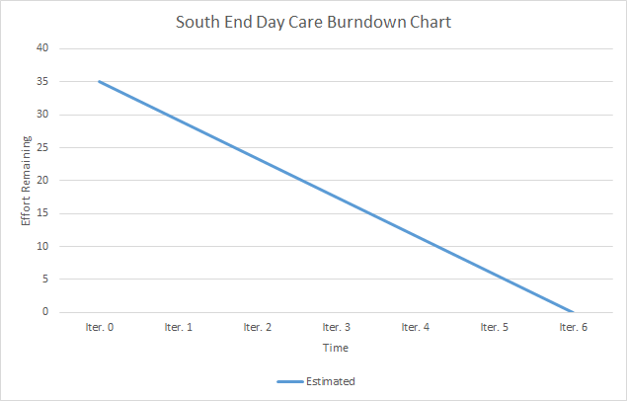  
  
Figure 1: Initial Project Burndown Chart

# Appendix A - Master List

